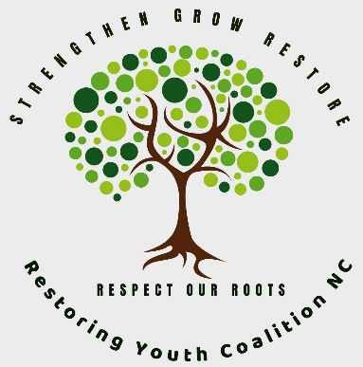
Restorative Justice Training Schedule
These trainings are for aspiring facilitators, including volunteers, who can work with community-based agencies and schools that provide restorative services for responsible youth and impacted parties. They include interactive learning and role-playing, allowing participants to practice how to facilitate school & community incidents, basic diversion and court-referred cases involving youth who have caused harm, victimized parties, and their family members and support people. ﻿
January-November 2026 – Virtual*
Restoring Youth Coalition of North Carolina
https://www.rjnc.us

REGISTER https://www.rjnc.us/trainings
Course Name | Dates | Class Hours | Assignment Hours | Total Hours | Time | Fee pp | Max Total Participants | Prerequisite
Including RJ Circles in Community Service - NEW | 2/17/26 | 2 | 0 | 2 | 10-12 | $50 | 20 | None
Your Enhanced Parental Conversation Toolbox - NEW | 2/19 | 2 | 0 | 2 | 10-12 | $50 | 20 | None
Train the Trainer – 4-hour Peaceful Parenting Class - NEW | 2/24 | 2 | 0 | 2 | 10-12 | $50 | 20 | None
Inviting Harmed Parties into the RJ Process - NEW | 2/26 | 2 | 0 | 2 | 10-12 | $50 | 20 | None
Peer Accountability Circles (aka Sentencing Circles) | 3/10, 12, 17, 19 | 8 | 7 | 15 | 10-12 | $200 | 20 | None
Youth Mediation | 4/9, 14, 16, 21, 23 | 10 | 7 | 17 | 10-12 | $225 | 20 | None
Truancy Mediation | 4/28 | 2 | 0 | 2 | 10-12 | $50 | 20 | Mediation
Youth Mediation to Arbitration (med/arb) - NEW | 4/30 | 2 | 0 | 2 | 10-12 | $50 | 20 | Mediation
Victim/Youth Conferencing | 5/12, 14, 19, 21 | 8 | 7 | 15 | 10-12 | $200 | 20 | Background in RJ Practices
Responsive Circles – Large Groups | 8/11, 13, 18, 20 | 8 | 7 | 15 | 10-12 | $200 | 20 | Background in RJ Practices
Adult Criminal Court Mediation | 9/8, 15, 22, 29 | 16 | 0 | 16 | 12:30-5 | $375 | 15 | Approved for State Certified
Including RJ Circles in Community Service - NEW | 10/20 | 2 | 0 | 2 | 10-12 | $50 | 20 | None
Your Enhanced Parental Conversation Toolbox – NEW | 10/22 | 2 | 0 | 2 | 10-12 | $50 | 20 | None
Train the Trainer - 4-hour Peaceful Parenting Class – NEW | 10/27 | 2 | 0 | 2 | 10-12 | $50 | 20 | None
Inviting Harmed Parties into the RJ Process - NEW | 10/29 | 2 | 0 | 2 | 10-12 | $50 | 20 | None
* In-person and virtual training available for groups of 5 or more; ** One make-up day provided for each course for a minimal fee
*** See definitions of the various RJ processes at https://www.rjprograms.com/restorative-justice-training and https://www.ncdps.gov/documents/files/divisions/jj/jcpc-and-community-programs-section-funded-programs-minimum-standards-policy/download?attachment

